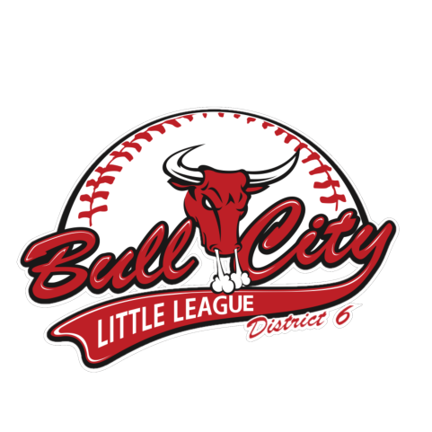

Bull City Little League Sponsorship

Thank you for considering partnering with us as a 2019 Bull City Little League sponsor. Without the generous contributions of volunteers, private individuals and business sponsorships, our mission would not be possible. We are deeply grateful for our community whose support has made Bull City Little League such a first-rate experience for our players and their families for many years. Bull City Little League is a 501(c)(3) organization.

To be successful, Bull City Little League depends on a tremendous amount of support from our local community. Your sponsorship helps us offset the costs of equipment, uniforms, field rentals, maintenance expenses, training materials and all the associated costs of conducting our League. It helps provide financial assistance to kids who would otherwise not be able to play. And you benefit, too, by being recognized as a supporter of the youth in our community!

As we prepare for the beginning of another fun season, we hope you will join us as part of our sponsorship community. From our Board of Directors, our families and volunteers, and most especially from our young baseball and softball players who have an exceptional Little League experience with your support . . . thank you!

For more information on sponsorship opportunities with Bull City Little League, contact our Fundraising committee at fundraisingbcll@gmail.com.

Bull City Little League Sponsorship Agreement

This agreement between the Little League
(hereinafter, “Local Little League”) and
(hereinafter, “Sponsor”) is for the season.

Sponsorship of the Local Little League must be, for the Sponsor, out of a sense of duty to help the community. While Sponsorship does afford some benefits (detailed below), the higher purpose is to help the Local Little League impart the values of teamwork, sportsmanship, and fair play to the children of the community, so that they may someday use these values in becoming good citizens.

Sponsorship of the Local Little League does not permit the Sponsor to have any rights or responsibilities in the operation of the Local Little League or any team in the Local Little League, nor does the Sponsor have any rights or responsibilities in the selection of managers, coaches or players for any team in the Local Little League. Nothing herein shall make us partners or joint ventures. The Sponsor and the Local Little League are independent contractors with respect to one another, and neither shall have any authority to represent or bind the other in any manner or to any extent whatsoever, except as specified herein.

Any reference to the Sponsorship under this agreement must make it clear that the Sponsorship is with the Local Little League ONLY, and NOT with Little League Baseball and Softball, the organization. Use of the marks of logos of Little League Baseball and Softball by any local sponsor is prohibited, unless permission is expressly granted in writing by Little League Baseball, Incorporated.

The Local Little League agrees to provide the following benefits in exchange for the sponsorship commitment:

______ GOLD GLOVE $300.00
- Yearbook & website recognition
- League Recognition Plaque to keep
- Exposure & recognition during spring 2019 season
- Small Logo on sponsorship board
- Regular season and tournament championships exposure

______ SILVER SLUGGER $750.00

- All the benefits of Gold Glove level
- Exposure & recognition during Fall 2019 season

______ MVP $1,500.00

- All the benefits of Gold Glove and Silver Slugger levels
- Email “blast” for your company 2x/year

______ BIG BULL $2,000.00

- All the benefits of Gold Glove, Silver Slugger and MVP levels
- Large Company logo (2x2) under scoreboard of Fields 1 or 3

______ HALL OF FAME $3,000.00

- All the benefits of Gold Glove, Silver Slugger, MVP and Big Bull levels
- Banner along fence on fields 1, 2, 3 or 4 (space and location varies upon availability)
- ¼ page-sized yearbook ad (Spring Season only)

For the above considerations, the Sponsor donates $ to the Local Little League, understanding that its donation is to benefit the entire league.

Additional Sponsorship Opportunities:

Yearbook Ad:
Local Little League’s yearbook is printed every Spring season and distributed to families of the Local Little League (1 per family) at no charge to them.

Ads in the yearbook are available for purchase at the following rates:

  - Business Card size - $25.00
  - ¼ Page - $40.00
  - ½ Page - $60.00
  - Full Page - $100.00

Art and design deadline: May 1, 2019

Team Sponsorship: $4,000

- Banner along fence on fields 1, 2, 3, or 4
- Sponsored team will carry banner during opening and closing ceremonies
- Sponsor’s logo will be printed on the team’s year book page
- Website recognition with web link
- Team recognition plaque to keep
- Sponsor recognition during major spring fundraiser event

Fence Banner: $1,000

- 4x8 foot full-color banner along the fence of your choice (prime visibility)

Sponsor Information

Sponsor Name __________________________________________________________

Sponsor Address _________________________________________________________

Sponsor Email ___________________________________________________________

Sponsor Phone Number ____________________________________________________

Sponsor Website _________________________________________________________

Acceptance & Agreement

Accepted and agreed to:

By
Sponsor Representative Signature Date

Printed or Typed Name Title

By
Local Little League Representative Signature Date

Printed or Typed Name

Please email a high-resolution company logo to fundraisingbcll@gmail.com.
Checks can be made payable and mailed to: Bull City Little League
P.O. Box 71181
Durham, NC 27712

Check #: ________

